HarryBot ATP Project Report
Rama Tamimi | Joud Wardeh
Bhacesehir University

1. Introduction
HarryBot is a domain-specific question-answer chatbot based on the Harry Potter world. With the help of a pre-curated Excel dataset containing details about Harry Potter, the bot fetches the appropriate information and combines it with the help of a large language model to frame an answer. The project spans the complete pipeline starting from fetching data and indexing until forming an answer in the form of a conversation-based web application.

2. Technology Stack
The following table summarises the core technologies used in the project:

Component | Technology
Programming Language | Python 3.11
Web Interface | Streamlit
Data Handling | pandas + openpyxl
Embedding Model | Sentence Transformers, all-MiniLM-L6-v2
Vector Search | FAISS, IndexFlatIP (cosine similarity)
LLM | Qwen-Plus via DashScope API (OpenAI-compatible)
LLM Client | openai Python SDK
Numerical Computing | NumPy

3. Flow Diagram
The figure below represents our work diagram:
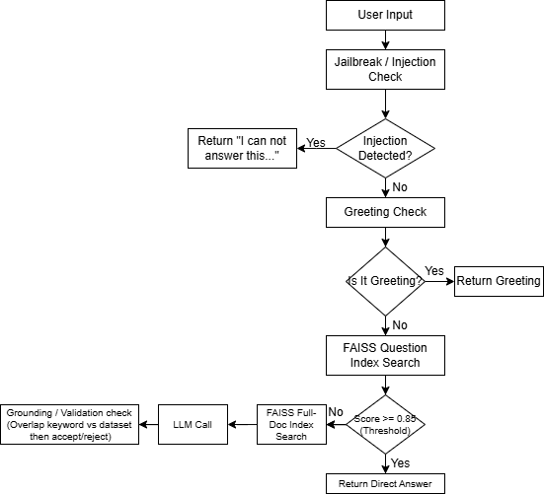

4. Parts We Found Difficult
Several aspects of the project presented meaningful technical challenges:

- Threshold tuning for FAISS: Tuning the threshold for similarity between the direct answer approach and the LLM context approach was difficult. If set to a low threshold, the bot returned the direct answer for questions that were not very relevant to it; if set to a higher one, it forced all questions to go through the LLM.
- Preventing LLM hallucinations: Despite having a strict system prompt, the LLM could generate some plausible facts that were not actually found within the training data. The tricky part when creating the grounding validator after the LLM's output was setting the word-level ratio threshold for identifying hallucinations without rejecting good answers.
- Jailbreak detection: Constructing a regex library that could potentially detect all the possible attempts at prompt injections without filtering out legitimate Harry Potter questions (for example: Describe Hermione) posed some challenges because it would provide answers outside of the data.
- Follow up questions: Even though we ensured building a strong system there were some struggles with having the bot remember the last question asked and accurately answering the next build up question based on the previous one such as “How old is harry potter?” then “What house is he in?”.

5. Parts We Enjoyed
Despite the challenges, several parts of the project were genuinely rewarding:

- Designing the themed Streamlit interface: Creating the black stone wall effect, using the four houses’ colours as a decoration bar, and the sidebars quotes from the harry potter series that are randomly chosen each time the interface is loaded gave the chatbot a true artifact feeling belonging to the wizarding world rather than a regular website.
- Building the RAG pipeline: Combining a fast direct-answer path with a context-synthesis path felt elegant once it came together. Watching the bot switch seamlessly between returning a precise dataset entry and calling the LLM with carefully assembled context was satisfying.
- Conversation memory: Seeing the bot correctly resolve follow-up questions, such as “How old is he?” after a question about Harry Potter and receive an accurate answer made the rolling-history feature feel genuinely useful.
- Working within the Harry Potter domain: The idea of the project itself matter made testing enjoyable. Running queries about spells, creatures, and characters provided instant, familiar feedback and kept the development process engaging throughout.

6. How to Run
Below are a set of sets to get the harrybot up and running:
- Install dependencies by running the following command in the terminal:
pip install -r requirements.txt
- Set your API key:
export API_KEY="your-api-key-here" (Linux/Mac)
or
set API_KEY=your-api-key-here (Windows)
- Run the chatbot (web UI) by running the following command in the terminal:
streamlit run app.py
- Ask harrybot your harry potter related questions!

